TUGAS INDIVIDU
Basis Data NoSQL
Aggregation Framework

DOSEN: M. Harry Khomas Saputra S.T., M.TI.
KIYOSHI OLOAN RAPHAEL SITORUS (225443012)



1AEC-1
TEKNOLOGI REKAYASA INFORMATIKA INDUSTRI
POLITEKNIK MANUFAKTUR BANDUNG
TAHUN AJARAN 2025/2026

- FASE 1 : Setup Lingkungan
  - Membuat file . env
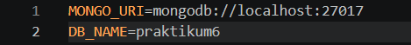

  - Membuat file koneksi.py
from dotenv import load_dotenv
from pymongo import MongoClient
from datetime import datetime, timedelta
import random, os

load_dotenv()
client = MongoClient(os.getenv("MONGO_URI"))
db = client[os.getenv("DB_NAME")]
collection = db["sensor"]

import os
from dotenv import load_dotenv
from pymongo import MongoClient

load_dotenv()
client = MongoClient(os.getenv("MONGO_URI"), serverSelectionTimeoutMS=5000)

try:
client.admin.command('ping')
print("Koneksi MongoDB berhasil!")
except Exception as e:
print("Gagal terhubung:", e)
finally:
client.close()

- FASE 2 : Operasi Dasar CRUD
  - Membuat file crud_sensor.py
from dotenv import load_dotenv
from pymongo import MongoClient
from datetime import datetime, timedelta
import random, os

load_dotenv()
client = MongoClient(os.getenv("MONGO_URI"))
db = client[os.getenv("DB_NAME")]
collection = db["sensor"]

  - Membuat file insert_many.py
from dotenv import load_dotenv
from pymongo import MongoClient
from datetime import datetime, timedelta
import random, os

load_dotenv()
client = MongoClient(os.getenv("MONGO_URI"))
db = client[os.getenv("DB_NAME")]
collection = db["sensor"]

data = []
for i in range(10):
doc = {
"mesin": f"CNC-{random.randint(1,3):02d}",
"suhu": round(random.uniform(60, 100), 2),
"getaran": round(random.uniform(0.1, 0.5), 2),
"timestamp": datetime.utcnow() - timedelta(minutes=i*5),
"status": "normal"
}
data.append(doc)
result = collection.insert_many(data)
print(f"Tersimpan {len(result.inserted_ids)} dokumen")
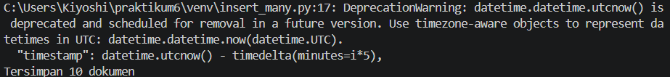

  - Membuat file read.py
from dotenv import load_dotenv
from pymongo import MongoClient
from datetime import datetime, timedelta
import random, os

load_dotenv()
client = MongoClient(os.getenv("MONGO_URI"))
db = client[os.getenv("DB_NAME")]
collection = db["sensor"]

cursor = collection.find(
{"mesin": "CNC-01"},
{"_id": 0, "suhu": 1, "timestamp": 1}
).sort("timestamp", -1).limit(5)
print("Data CNC-01 terbaru:")
for doc in cursor:
print(doc)
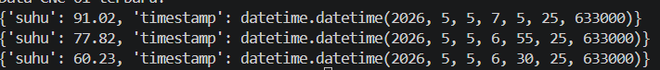

  - Membuat file update.py
from dotenv import load_dotenv
from pymongo import MongoClient
from datetime import datetime, timedelta
import random, os

load_dotenv()
client = MongoClient(os.getenv("MONGO_URI"))
db = client[os.getenv("DB_NAME")]
collection = db["sensor"]

update_result = collection.update_many(
{"suhu": {"$gt": 90}},
{"$set": {"status": "maintenance"}}
)
print(f"Update: {update_result.modified_count} dokumen diubah")

  - Membuat delete.py
from dotenv import load_dotenv
from pymongo import MongoClient
from datetime import datetime, timedelta
import random, os

load_dotenv()
client = MongoClient(os.getenv("MONGO_URI"))
db = client[os.getenv("DB_NAME")]
collection = db["sensor"]

satu_jam_lalu = datetime.utcnow() - timedelta(hours=1)
delete_result = collection.delete_many({"timestamp": {"$lt": satu_jam_lalu}})
print(f"Delete: {delete_result.deleted_count} dokumen dihapus")
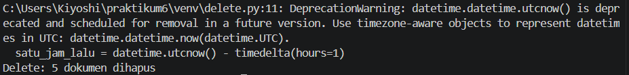

- FASE 3 : Agregasi via Python
  - Membuat file agregasi.py
import os
from dotenv import load_dotenv
from pymongo import MongoClient

load_dotenv()
client = MongoClient(os.getenv("MONGO_URI"))
db = client[os.getenv("DB_NAME")]
collection = db["sensor"]

pipeline = [
{"$group": {
"_id": "$mesin",
"rata_suhu": {"$avg": "$suhu"},
"max_getaran": {"$max": "$getaran"},
"count": {"$sum": 1}
}},
{"$sort": {"rata_suhu": -1}}
]

results = collection.aggregate(pipeline)
print("Rata-rata suhu per mesin:")
for doc in results:
print(f"{doc['_id']} -> rata:{doc['rata_suhu']:.2f}°C, max getaran:{doc['max_getaran']}, jumlah data:{doc['count']}")

client.close()
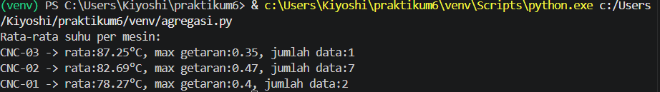

- FASE 4 : Analisis dengan pandas
  - Membuat file analisis.py
import os
import pandas as pd
import matplotlib.pyplot as plt
from dotenv import load_dotenv
from pymongo import MongoClient

load_dotenv()
client = MongoClient(os.getenv("MONGO_URI"))
db = client[os.getenv("DB_NAME")]
collection = db["sensor"]

cursor = collection.find({}, {"_id": 0})
df = pd.DataFrame(list(cursor))

df['timestamp'] = pd.to_datetime(df['timestamp'])
df.set_index('timestamp', inplace=True)

resampled = df.resample('10min').mean(numeric_only=True)
print(resampled.head())

plt.figure(figsize=(10,5))
df['suhu'].plot(title='Suhu dari Waktu ke Waktu')
plt.ylabel('Suhu (°C)')
plt.grid(True)
plt.savefig('suhu_plot.png')
plt.show()

client.close()
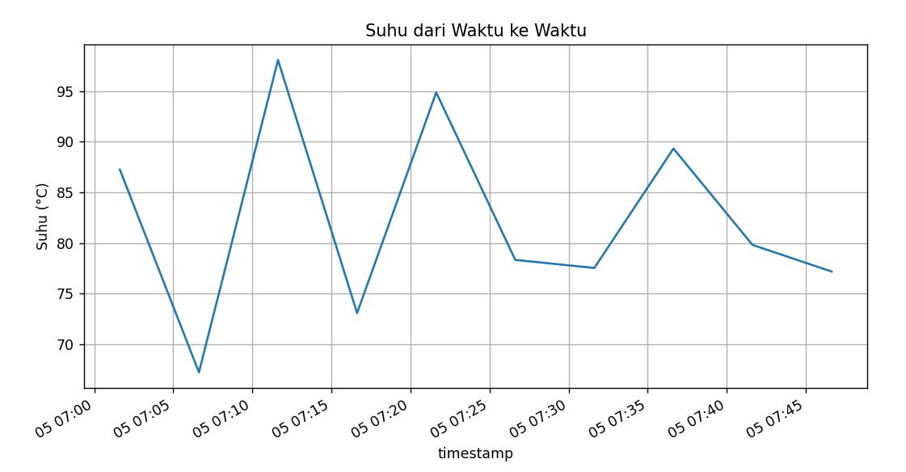

- FASE 5 : Data Generator Langsung
  - Membuat file data_generator.py
import time, random
from datetime import datetime
from pymongo import MongoClient
import os
from dotenv import load_dotenv

load_dotenv()
client = MongoClient(os.getenv("MONGO_URI"))
db = client[os.getenv("DB_NAME")]
collection = db["sensor"]

while True:
doc = {
"mesin": f"CNC-{random.randint(1,5):02d}",
"suhu": round(random.uniform(60, 100), 2),
"getaran": round(random.uniform(0.1, 0.5), 2),
"timestamp": datetime.utcnow()
}
collection.insert_one(doc)
print(f"[{datetime.utcnow()}] Inserted: {doc['mesin']} - {doc['suhu']}°C")
time.sleep(2)
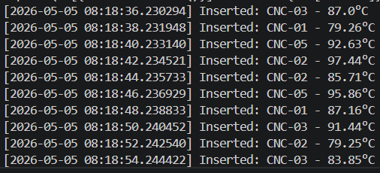

- FASE 5B (lanjutan) :
  - Membuat file mqtt_publisher.py
import json, time, random
import paho.mqtt.client as mqtt
from datetime import datetime

BROKER = "test.mosquitto.org"
PORT = 1883
TOPIC = "pabrik/sensor/suhu"

client = mqtt.Client()
client.connect(BROKER, PORT, 60)

while True:
data = {
"mesin": f"CNC-{random.randint(1,5):02d}",
"suhu": round(random.uniform(60, 100), 2),
"getaran": round(random.uniform(0.1, 0.5), 2),
"timestamp": datetime.utcnow().isoformat()
}
payload = json.dumps(data)
client.publish(TOPIC, payload)
print(f"[PUB] {payload}")
time.sleep(2)
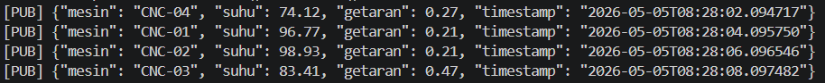

  - Membuat file mqtt_subscriber.py
import json, os
import paho.mqtt.client as mqtt
from pymongo import MongoClient
from datetime import datetime
from dotenv import load_dotenv

load_dotenv()
MONGO_URI = os.getenv("MONGO_URI")
DB_NAME = os.getenv("DB_NAME")

mongo_client = MongoClient(MONGO_URI)
db = mongo_client[DB_NAME]
collection = db["sensor"]

def on_connect(client, userdata, flags, rc):
print("Terhubung ke MQTT broker")
client.subscribe("pabrik/sensor/suhu")

def on_message(client, userdata, msg):
try:
payload = json.loads(msg.payload.decode())
payload['timestamp'] = datetime.fromisoformat(payload['timestamp'])
result = collection.insert_one(payload)
print(f"[MONGO] Tersimpan {result.inserted_id} - {payload['mesin']} {payload['suhu']}°C")
except Exception as e:
print("Error:", e)

mqtt_client = mqtt.Client()
mqtt_client.on_connect = on_connect
mqtt_client.on_message = on_message
mqtt_client.connect("test.mosquitto.org", 1883, 60)
mqtt_client.loop_forever()
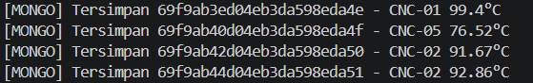

- FASE 6 : Error Handlling dan Logging
  - Contoh penambahan logging pada crud_sensor.py (di awal file), kemudian bungkus insert_many dengan try-except:
from dotenv import load_dotenv
from pymongo import MongoClient
from datetime import datetime, timedelta
import random, os

load_dotenv()
client = MongoClient(os.getenv("MONGO_URI"))
db = client[os.getenv("DB_NAME")]
collection = db["sensor"]

import logging
logging.basicConfig(
level=logging.INFO,
format='%(asctime)s - %(levelname)s - %(message)s',
handlers=[
logging.FileHandler("crud_sensor.log"),
logging.StreamHandler()
]
)

try:
result = collection.insert_many(data)
logging.info(f"Insert berhasil, {len(result.inserted_ids)} dokumen")
except Exception as e:
logging.error(f"Insert gagal: {e}")

